14.25: a) 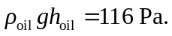

b)

c) 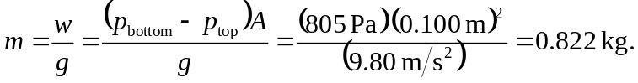
The density of the block is 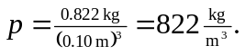 Note that is the same as the average density of the fluid displaced,

